Experiment No: 01
Experiment Name: Introduction to Basic Bash Commands and File System Management.
Theory: Bash is a command-line interpreter that allows users to interact with the Linux operating system by executing text-based commands. It provides direct control over file system management through commands that navigate directories, create and modify files, and manage system resources. Commands like `pwd` and `cd` handle navigation, while `ls` lists contents. `mkdir` and `touch` create directories and files, `nano` edits them, and `cat` displays contents. `rm` and `rmdir` remove files and directories, enabling efficient system administration.
Command | Description
whoami | Displays the current username of the logged-in user.
pwd | Prints the present working directory (full path of current location).
ls | Lists all files and directories in the current directory.
cd | Changes the current directory to the home directory.
cd .. | Moves up one level to the parent directory.
clear | Clears the terminal screen of all previous text and output.
mkdir | Creates a new empty directory.
mkdir folder1 folder2 | Creates multiple directories at once.
touch filename.extension | Creates a new empty file with the specified name.
cat filename.extension | Displays the contents of a file on the terminal.
nano | Opens the nano text editor for creating or editing files.
rm | Removes (deletes) a file.
rmdir | Removes an empty directory.
rm -rf | Forcefully removes files and directories recursively (use with caution).

Commands and Output:
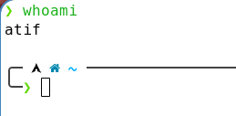
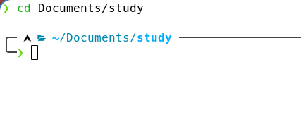
- whoami
- cd

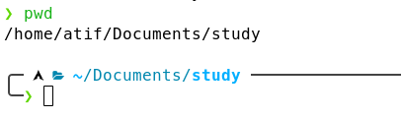
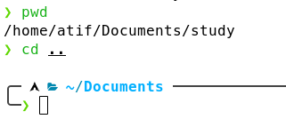
- pwd
- cd ..
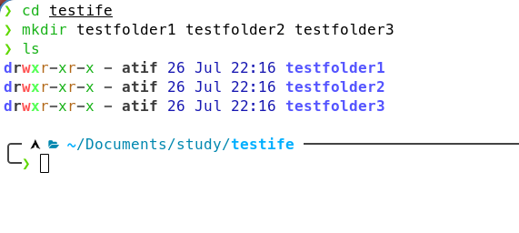
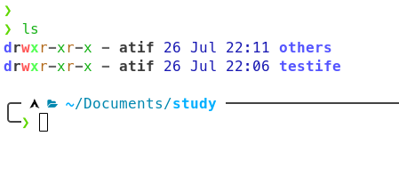
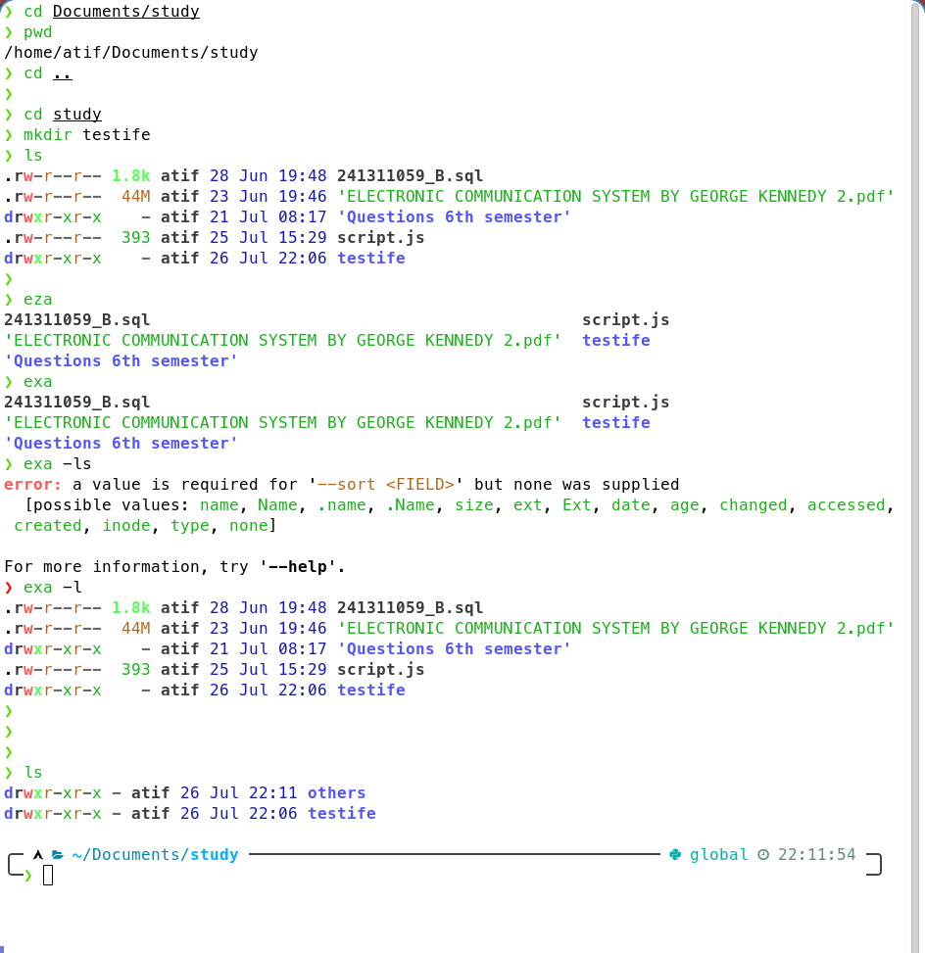

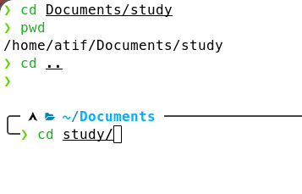
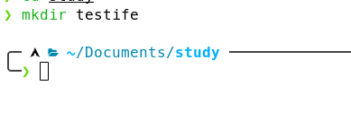
- mkdir foldernames
- ls
- Before clear
- clear
- cd Tab
- mkdir
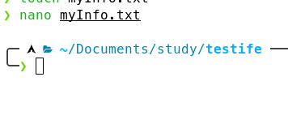
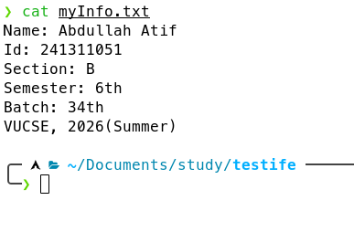
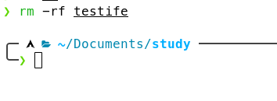
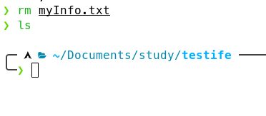
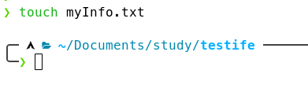
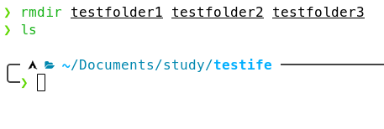
- nano
- cat
- rm -rf
- rm
- touch
- rmdir

Discussion:
This experiment demonstrated the role of Bash commands in Linux file system management. Commands like pwd, cd, and ls enabled directory navigation, while mkdir and touch facilitated file creation. Nano and cat allowed content viewing and editing, whereas rm and rmdir handled deletion. Using rm -rf highlighted the need for caution with recursive deletion to prevent data loss. We acquired practical skills in basic Bash operations for Linux administration. These commands provide a solid foundation for advanced scripting and command-line workflow.

